If you only attend one training event for 2018, this is the one!

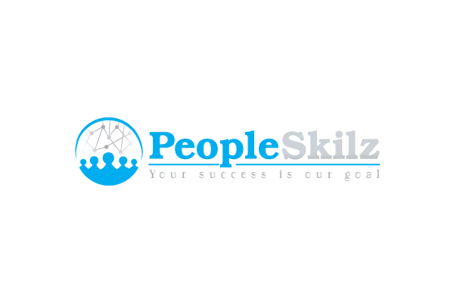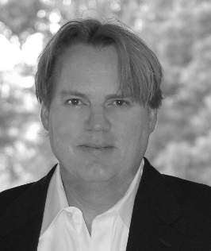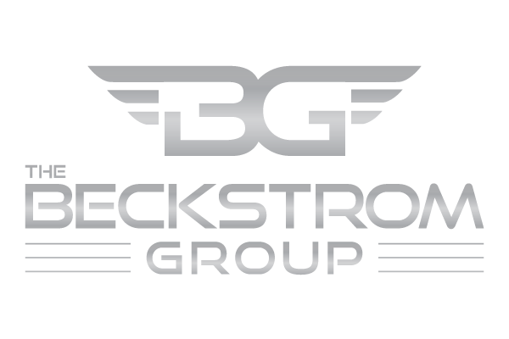
Body Language and Nonverbal Communication for Business Professionals Seminar
The quintessential professional development course for individuals who want to increase their ability to connect and develop rapport with people.
“The best crash course in body language on the market today”.
“I can’t believe how much I learned, and how relevant and powerful nonverbal communication is in business. My eyes were opened.”
“Terry Beckstrom delivers a dynamic information packed training course that will keep you on the edge of your seat.”
Wednesday January 31, 2018 at the Raleigh Convention Center in Raleigh, N.C.
8-8:30 (registration)
8:30am-4:00pm (training)
1-hour lunch break – on your own
*Special Pricing for this Event: $120 pre-registered (or $150 at the door)
Businesses are encouraged to send representatives to the course, and individuals without a business affiliation are of course welcomed. Limited seating is available, and attendees are expected from multiple states. Please sign up early to reserve your seat
Register Now

